12576 - Nisanth Saravanan
L1 .NET & C# Assessment

Digital Receipt Management System

Digital Receipt Management System:
Stores and categorizes digital receipts for personal or business use.

Entities:
Receipt, Vendor, Category, User, ExpenseReport

Please find the assigned case study and perform below actions:
Task:
- Perform W3H analysis on the given Case Study.
- Create a Console application for the given scenario
- Configure MySQL server and create database and tables as per need.
- Perform all the CRUD operations using ADO.NET on the given entity.

- Add data
- Search data by id
- Update data by id
- Delete data by id
- Display all data
- Application must be the Responsive and User-friendly menu items.

GitHub Link:

RelevantzRIX2024/Assessments/.NET C# at 12576_Nisanth · benhar-velankanni/RelevantzRIX2024

W3H Analysis

Project Title: Digital Receipt Management System
What? |  | How?
1.What are the Modules/Functionalities needed?  A: Modules/Functionalities Required:  a) Adding Functionality.  b) Display Functionality.  c) Search Functionality.  d) Delete Functionality.  e) Update Functionality.  2. What are the requirements of Adding Functionality?  A: Adding Functionality:  a) Get User Input.  b) Validate user input.  c) Inject new data into the SQL Database.  3. What are the requirements of the Display functionality?  A: Display Functionality:  a) Get data from SQL database.  a) Display data.  4. What are the requirements of the Search functionality?  A: Search Functionality:  a) Get ID as input.  b) To display search results.  5. What are the requirements of the Delete Functionality?  A: Delete Functionality:  a) Get ID as input.  b) To display deletion results.  6. What are the requirements of the Update Functionality?  A: Update Functionality:  a) Get User Input.  b) Validate user input.  c) Update new data into the SQL Database. |  | 1. Adding Functionality:  a) Get User Input:  Method 1: Get input via Dedicated Methods.  Method 2: Get input via simple Input Statements.  Method 3: Get input via File Reader.  b) Validate user input:  Method 1: Using Input Helper Methods.  Method 2: Using While Loop.  Method 3: Using a series of Conditional Statements.  c) Inject new data into the SQL Database:  Method 1: Using MySQL connection and command mechanism.  Method 2: Using manual data injection.  Method 3: Using File Writer and storing the file in database.  2. Display Functionality:  a) Get data from SQL database:  Method 1: Using MySQL connection and command mechanism.  Method 2: Using manual data collection.  Method 3: Using File Reader and a single database file.  a) Display data:  Method 1: Using simple Output statements.  Method 2: Using File Writer.  Method 3: Using Dedicated Output Helper Methods.  3. Search Functionality:  a) Get ID as input:  Method 1: Get input via Dedicated Methods.  Method 2: Get input via simple Input Statements.  Method 3: Get input via Conditional Parser.  b) To display search results:  Method 1: Using simple Output statements.  Method 2: Using File Writer.  Method 3: Using Dedicated Output Helper Methods.  4. Delete Functionality:  a) Get ID as input:  Method 1: Get input via Dedicated Methods.  Method 2: Get input via simple Input Statements.  Method 3: Get input via Conditional Parser.  b) To display deletion results:  Method 1: Using simple Output statements.  Method 2: Using File Writer.  Method 3: Using Dedicated Output Helper Methods.  5. Update Functionality:  a) Get User Input:  Method 1: Get input via Dedicated Methods.  Method 2: Get input via simple Input Statements.  Method 3: Get input via File Reader.  b) Validate user input:  Method 1: Using Input Helper Methods.  Method 2: Using While Loop.  Method 3: Using a series of Conditional Statements.  c) Inject new data into the SQL Database:  Method 1: Using MySQL connection and command mechanism.  Method 2: Using manual data injection.  Method 3: Using File Writer and storing the file in database.
1. Adding Functionality:  a) Get User Input:  Method 1: Get input via Dedicated Methods.  A: Efficient and promotes reusability.  b) Validate user input:  Method 1: Using Input Helper Methods.  A: Efficient and promotes reusability.  c) Inject new data into the SQL Database:  Method 1: Using MySQL connection and command mechanism.  A: Simple to implement but is effective for our cause.  2. Display Functionality:  a) Get data from SQL database:  Method 1: Using MySQL connection and command mechanism.  A: Simple to implement but is effective for our cause.  a) Display data:  Method 1: Using simple Output statements.  A: Simple to implement but is effective for our cause.  3. Search Functionality:  a) Get ID as input:  Method 3: Get input via Conditional Parser.  A: Simple to implement but is effective for our cause.  b) To display search results:  Method 1: Using simple Output statements.  A: Simple to implement but is effective for our cause.  4. Delete Functionality:  a) Get ID as input:  Method 3: Get input via Conditional Parser.  A: Simple to implement but is effective for our cause.  b) To display deletion results:  Method 1: Using simple Output statements.  A: Simple to implement but is effective for our cause.  5. Update Functionality:  a) Get User Input:  Method 1: Get input via Dedicated Methods.  A: Efficient and promotes reusability.  b) Validate user input:  Method 1: Using Input Helper Methods.  A: Efficient and promotes reusability.  c) Inject new data into the SQL Database:  Method 1: Using MySQL connection and command mechanism.  A: Simple to implement but is effective for our cause. |  | 1. Adding Functionality:  a) Get User Input:  Method 2: Get input via simple Input Statements.  Method 3: Get input via File Reader.  A: Inefficient and round-about method respectively  b) Validate user input:  Method 2: Using While Loop.  Method 3: Using a series of Conditional Statements.  A: Valid methods but less efficient on their own.  c) Inject new data into the SQL Database:  Method 2: Using manual data injection.  Method 3: Using File Writer and storing the file in database.  A: Inefficient and round-about method respectively  2. Display Functionality:  a) Get data from SQL database:  Method 2: Using manual data collection.  Method 3: Using File Reader and a single database file.  A: Inefficient and round-about method respectively  a) Display data:  Method 2: Using File Writer.  Method 3: Using Dedicated Output Helper Methods.  A: Inefficient and round-about method respectively  3. Search Functionality:  a) Get ID as input:  Method 1: Get input via Dedicated Methods.  Method 2: Get input via simple Input Statements.  A: Increases the lines of code with no valid justification.  b) To display search results:  Method 2: Using File Writer.  Method 3: Using Dedicated Output Helper Methods.  A: Inefficient and round-about method respectively  4. Delete Functionality:  a) Get ID as input:  Method 1: Get input via Dedicated Methods.  Method 2: Get input via simple Input Statements.  A: Increases the lines of code with no valid justification.  b) To display deletion results:  Method 2: Using File Writer.  Method 3: Using Dedicated Output Helper Methods.  A: Inefficient and round-about method respectively  5. Update Functionality:  a) Get User Input:  Method 2: Get input via simple Input Statements.  Method 3: Get input via File Reader.  A: Inefficient and round-about method respectively  b) Validate user input:  Method 2: Using While Loop.  Method 3: Using a series of Conditional Statements.  A: Valid methods but less efficient on their own.  c) Inject new data into the SQL Database:  Method 2: Using manual data injection.  Method 3: Using File Writer and storing the file in database.  A: Inefficient and round-about method respectively
Why? |  | Why Not?

CODE

Database Schema

CREATE TABLE DIGIRECEIPT (
ID INT AUTO_INCREMENT PRIMARY KEY,
RECEIPTNAME VARCHAR(50),
RECEIPTAMOUNT DECIMAL(10,2),
CATEGORY VARCHAR(50),
DATE VARCHAR(10),
ADDITIONALNOTES VARCHAR(500));
Program.cs

namespace DigiReceiptApp
{
public class Program
{
public static void Main(String[] args)
{
Console.WriteLine("\n====================================================\nWELCOME TO OUR APPLICATION.\n====================================================");

string connectionString = "Server=localhost;User=root;Password=Reset@123;Database=RELEVANTZ;Port=3306;";

IDigiReceiptService digiReceiptService = new DigiReceiptService(connectionString);
DigiReceiptUI digiReceiptUI = new DigiReceiptUI(digiReceiptService);

while (true)
{
Console.WriteLine("\n====================================================\nMENU:\n====================================================");
Console.WriteLine("1. ADD RECEIPT.");
Console.WriteLine("2. GET RECEIPT BY ID.");
Console.WriteLine("3. GET ALL RECEIPTS.");
Console.WriteLine("4. UPDATE RECEIPT.");
Console.WriteLine("5. DELETE RECEIPT.");
Console.WriteLine("6. TRUNCATE RECEIPTS.");
Console.WriteLine("0. EXIT.");
Console.WriteLine("====================================================");
Console.WriteLine("ENTER YOUR CHOICE:");

if (int.TryParse(Console.ReadLine(), out int choice))
{
switch (choice)
{
case 1:
DigiReceiptUI.AddReceiptUI();
break;
case 2:
DigiReceiptUI.GetReceiptByIdUI();
break;
case 3:
DigiReceiptUI.GetAllReceiptsUI();
break;
case 4:
DigiReceiptUI.UpdateDigiReceiptUI();
break;
case 5:
DigiReceiptUI.DeleteDigiReceiptUI();
break;
case 6:
DigiReceiptUI.TruncateDigiReceiptUI();
break;
case 0:
Console.WriteLine("\n====================================================\nTHANK YOU FOR USING OUR APPLICATION.\n====================================================");
return;
default:
Console.WriteLine("\n====================================================\nINVALID CHOICE. PLEASE TRY AGAIN.\n====================================================");
break;
}
}
else
{
Console.WriteLine("\n====================================================\nINVALID INPUT. PLEASE TRY AGAIN.\n====================================================");
}
}
}
}
}

DigiReceipt.cs

using System.Text.RegularExpressions;
using MySql.Data.MySqlClient;

namespace DigiReceiptApp
{
public class DigiReceipt
{
public int? ID { get; set; }
public string? RECEIPTNAME { get; set; }
public decimal? RECEIPTAMOUNT { get; set; }
public string? CATEGORY { get; set; }
public string? DATE { get; set; }
public string? ADDITIONALNOTES { get; set; }
}

public interface IDigiReceiptService
{
void AddReceipt(DigiReceipt digiReceipt);
DigiReceipt GetDigiReceiptByID(int id);
List<DigiReceipt> GetAllDigiReceipts();
bool UpdateDigiReceipt(int id, DigiReceipt digiReceipt);
bool DeleteDigiReceipt(int id);
bool TruncateDigiReceipt();
}

public class DigiReceiptService : IDigiReceiptService
{
private readonly string _connectionString;

public DigiReceiptService(string connectionString)
{
_connectionString = connectionString;
}

public void AddReceipt(DigiReceipt digiReceipt)
{
try
{
using (var connection = new MySqlConnection(_connectionString))
{
connection.Open();
using (var command = new MySqlCommand("INSERT INTO DIGIRECEIPT (RECEIPTNAME, RECEIPTAMOUNT, CATEGORY, DATE, ADDITIONALNOTES) VALUES (@name, @amount, @category, @date, @notes)", connection))
{
command.Parameters.AddWithValue("@name", digiReceipt.RECEIPTNAME);
command.Parameters.AddWithValue("@amount", digiReceipt.RECEIPTAMOUNT);
command.Parameters.AddWithValue("@category", digiReceipt.CATEGORY);
command.Parameters.AddWithValue("@date", digiReceipt.DATE);
command.Parameters.AddWithValue("@notes", digiReceipt.ADDITIONALNOTES);
command.ExecuteNonQuery();
}
}
}
catch (Exception ex)
{
throw new Exception($"Error adding receipt: {ex.Message}", ex);
}
}

public DigiReceipt GetDigiReceiptByID(int id)
{
try
{
using (var connection = new MySqlConnection(_connectionString))
{
connection.Open();
using (var command = new MySqlCommand("SELECT * FROM DIGIRECEIPT WHERE ID = @id", connection))
{
command.Parameters.AddWithValue("@id", id);
using (var reader = command.ExecuteReader())
{
if (reader.Read())
{
return new DigiReceipt
{
ID = reader.GetInt32("ID"),
RECEIPTNAME = reader.GetString("RECEIPTNAME"),
RECEIPTAMOUNT = reader.GetDecimal("RECEIPTAMOUNT"),
CATEGORY = reader.GetString("CATEGORY"),
DATE = reader.GetString("DATE"),
ADDITIONALNOTES = reader.GetString("ADDITIONALNOTES")
};
}
}
}
}
}
catch (Exception ex)
{
throw new Exception($"Error getting receipt by ID: {ex.Message}", ex);
}
return null;
}

public List<DigiReceipt> GetAllDigiReceipts()
{
var digiReceipts = new List<DigiReceipt>();

try
{
using (var connection = new MySqlConnection(_connectionString))
{
connection.Open();
using (var command = new MySqlCommand("SELECT * FROM DIGIRECEIPT", connection))
{
using (var reader = command.ExecuteReader())
{
if (reader.HasRows)
{
while (reader.Read())
{
digiReceipts.Add(new DigiReceipt
{
ID = reader.GetInt32("ID"),
RECEIPTNAME = reader.GetString("RECEIPTNAME"),
RECEIPTAMOUNT = reader.GetDecimal("RECEIPTAMOUNT"),
CATEGORY = reader.GetString("CATEGORY"),
DATE = reader.GetString("DATE"),
ADDITIONALNOTES = reader.GetString("ADDITIONALNOTES")
});
}

return digiReceipts;
}
else
{
return null;
}
}
}
}
}
catch (Exception ex)
{
throw new Exception($"Error getting all receipts: {ex.Message}", ex);
}
}

public bool UpdateDigiReceipt(int id, DigiReceipt digiReceipt)
{
try
{
using (var connection = new MySqlConnection(_connectionString))
{
connection.Open();
using (var command = new MySqlCommand("UPDATE DIGIRECEIPT SET RECEIPTNAME = @name, RECEIPTAMOUNT = @amount, CATEGORY = @category, DATE = @date, ADDITIONALNOTES = @notes WHERE ID = @id", connection))
{
command.Parameters.AddWithValue("@id", id);
command.Parameters.AddWithValue("@name", digiReceipt.RECEIPTNAME);
command.Parameters.AddWithValue("@amount", digiReceipt.RECEIPTAMOUNT);
command.Parameters.AddWithValue("@category", digiReceipt.CATEGORY);
command.Parameters.AddWithValue("@date", digiReceipt.DATE);
command.Parameters.AddWithValue("@notes", digiReceipt.ADDITIONALNOTES);
int rowsAffected = command.ExecuteNonQuery();
return rowsAffected > 0;
}
}
}
catch (Exception ex)
{
throw new Exception($"Error updating receipt: {ex.Message}", ex);
}
}

public bool DeleteDigiReceipt(int id)
{
try
{
using (var connection = new MySqlConnection(_connectionString))
{
connection.Open();
using (var command = new MySqlCommand("DELETE FROM DIGIRECEIPT WHERE ID = @id", connection))
{
command.Parameters.AddWithValue("@id", id);
int rowsAffected = command.ExecuteNonQuery();
return rowsAffected > 0;
}
}
}
catch (Exception ex)
{
throw new Exception($"Error deleting receipt: {ex.Message}", ex);
}
}

public bool TruncateDigiReceipt()
{
try
{
using (var connection = new MySqlConnection(_connectionString))
{
connection.Open();
using (var command = new MySqlCommand("TRUNCATE TABLE DIGIRECEIPT", connection))
{
int rowsAffected = command.ExecuteNonQuery();
return rowsAffected > 0;
}
}
}
catch (Exception ex)
{
Console.WriteLine($"\n====================================================\nERROR IN TRUNCATING RECEIPT: {ex.Message} \n====================================================");
}
return false;
}

}

public class DigiReceiptUI
{
public static IDigiReceiptService _digiReceiptService;

public DigiReceiptUI(IDigiReceiptService digiReceiptService)
{
_digiReceiptService = digiReceiptService;
}

public static void AddReceiptUI()
{
Console.WriteLine("\n====================================================\nADD RECEIPT:\n====================================================");

var name = GetValidName();
Console.WriteLine();
var amount = GetValidAmount();
Console.WriteLine();
var category = GetValidCategory();
Console.WriteLine();
var date = GetValidDate();
Console.WriteLine();
var notes = GetValidNotes();
Console.WriteLine();

Console.WriteLine("====================================================");

var digiReceipt = new DigiReceipt
{
RECEIPTNAME = name,
RECEIPTAMOUNT = amount,
CATEGORY = category,
DATE = date,
ADDITIONALNOTES = notes
};

try
{
_digiReceiptService.AddReceipt(digiReceipt);
Console.WriteLine("\n====================================================\nRECEIPT ADDED SUCCESSFULLY.\n====================================================");
}
catch (Exception ex)
{
Console.WriteLine($"\n====================================================\nERROR: {ex.Message} \n====================================================");
}
}

public static void GetAllReceiptsUI()
{
Console.WriteLine("\n====================================================\nGET ALL RECEIPTS:\n====================================================");
Console.WriteLine();

try
{
var digiReceipts = _digiReceiptService.GetAllDigiReceipts();
if (digiReceipts != null)
{
foreach (var digiReceipt in digiReceipts)
{
Console.WriteLine($"Receipt ID: {digiReceipt.ID}");
Console.WriteLine($"Receipt Name: {digiReceipt.RECEIPTNAME}");
Console.WriteLine($"Receipt Amount: {digiReceipt.RECEIPTAMOUNT}");
Console.WriteLine($"Category of Expenditure: {digiReceipt.CATEGORY}");
Console.WriteLine($"Date of Expenditure: {digiReceipt.DATE}");
if (digiReceipt.ADDITIONALNOTES != "")
{
Console.WriteLine($"Additional Notes: {digiReceipt.ADDITIONALNOTES}");
}
else
{
Console.WriteLine($"Additional Notes: N/A");
}
Console.WriteLine("====================================================");
}
}
else
{
Console.WriteLine("\n====================================================\nNO RECEIPTS FOUND.\n====================================================");
}
}
catch (Exception ex)
{
Console.WriteLine($"\n====================================================\nERROR: {ex.Message} \n====================================================");
}
}

public static void GetReceiptByIdUI()
{
Console.WriteLine("\n====================================================\nGET RECEIPT BY ID:\n====================================================");
Console.WriteLine();

if (int.TryParse(Console.ReadLine(), out int id))
{
try
{
var digiReceipt = _digiReceiptService.GetDigiReceiptByID(id);
if (digiReceipt != null)
{
Console.WriteLine($"Receipt ID: {digiReceipt.ID}");
Console.WriteLine($"Receipt Name: {digiReceipt.RECEIPTNAME}");
Console.WriteLine($"Receipt Amount: {digiReceipt.RECEIPTAMOUNT}");
Console.WriteLine($"Category of Expenditure: {digiReceipt.CATEGORY}");
Console.WriteLine($"Date of Expenditure: {digiReceipt.DATE}");
if (digiReceipt.ADDITIONALNOTES != "")
{
Console.WriteLine($"Additional Notes: {digiReceipt.ADDITIONALNOTES}");
}
else
{
Console.WriteLine($"Additional Notes: N/A");
}
Console.WriteLine("====================================================");
}
else
{
Console.WriteLine("\n====================================================\nNO RECEIPT FOUND WITH THE GIVEN ID.\n====================================================");
}
}
catch (Exception ex)
{
Console.WriteLine($"\n====================================================\nERROR: {ex.Message} \n====================================================");
}
}
else
{
Console.WriteLine("\n====================================================\nINVALID ID FORMAT. PLEASE ENTER A NUMBER.\n====================================================");
}
}

public static void UpdateDigiReceiptUI()
{
Console.WriteLine("\n====================================================\nUPDATE RECEIPT: ENTER RECIEPT ID:\n====================================================");
Console.WriteLine();

if (int.TryParse(Console.ReadLine(), out int id))
{
var digiReceipt = _digiReceiptService.GetDigiReceiptByID(id);
if (digiReceipt != null)
{
Console.WriteLine("\n====================================================\nENTER NEW RECEIPT DETAILS:\n====================================================");
var name = GetValidName();
Console.WriteLine();
var amount = GetValidAmount();
Console.WriteLine();
var category = GetValidCategory();
Console.WriteLine();
var date = GetValidDate();
Console.WriteLine();
var notes = GetValidNotes();
Console.WriteLine();

Console.WriteLine("====================================================");

digiReceipt.RECEIPTNAME = name;
digiReceipt.RECEIPTAMOUNT = amount;
digiReceipt.CATEGORY = category;
digiReceipt.DATE = date;
digiReceipt.ADDITIONALNOTES = notes;

try
{
bool result = _digiReceiptService.UpdateDigiReceipt(id, digiReceipt);
if (result)
{
Console.WriteLine("\n====================================================\nRECEIPT UPDATED SUCCESSFULLY.\n====================================================");
}
else
{
Console.WriteLine("\n====================================================\nRECEIPT UPDATION FAILED.\n====================================================");
}
}
catch (Exception ex)
{
Console.WriteLine($"\n====================================================\nERROR: {ex.Message} \n====================================================");
}
}
else
{
Console.WriteLine("\n====================================================\nNO RECEIPT FOUND WITH THE GIVEN ID.\n====================================================");
}
}
}

public static void DeleteDigiReceiptUI()
{
Console.WriteLine("\n====================================================\nDELETE RECEIPT: ENTER RECIEPT ID:\n====================================================");

if (int.TryParse(Console.ReadLine(), out int id))
{
try
{
bool result = _digiReceiptService.DeleteDigiReceipt(id);
if (result)
{
Console.WriteLine("\n====================================================\nRECEIPT DELETED SUCCESSFULLY.\n====================================================");
}
else
{
Console.WriteLine("\n====================================================\nRECEIPT DELETION FAILED.\n====================================================");
}
}
catch (Exception ex)
{
Console.WriteLine($"\n====================================================\nERROR: {ex.Message} \n====================================================");
}
}
else
{
Console.WriteLine("\n====================================================\nINVALID ID FORMAT. PLEASE ENTER A NUMBER.\n====================================================");
}
}

public static void TruncateDigiReceiptUI()
{
Console.WriteLine("\n====================================================\nTRUNCATE RECEIPT:\n====================================================");

Console.Write("Confirmation: All existing data will be deleted. Press Y to continue: ");
string? choice = Console.ReadLine().ToUpper();

if (choice == "Y")
{
try
{
_digiReceiptService.TruncateDigiReceipt();
Console.WriteLine("\n====================================================\nRECEIPT TABLE TRUNCATED SUCCESSFULLY.\n====================================================");
}
catch (Exception ex)
{
Console.WriteLine($"\n====================================================\nERROR: {ex.Message} \n====================================================");
}
}
else
{
Console.WriteLine("\n====================================================\nOPERATION CANCELLED.\n====================================================");
}
}

private static string GetValidName()
{
while (true)
{
Console.WriteLine("Enter a valid receipt name:");
var name = Console.ReadLine();
if (!string.IsNullOrWhiteSpace(name))
{
return name;
}
Console.WriteLine("Invalid name. Please try again.");
}
}

private static decimal GetValidAmount()
{
while (true)
{
Console.WriteLine("Enter a valid amount (INR):");
if (decimal.TryParse(Console.ReadLine(), out decimal amount))
{
if (amount >= 0)
{
return Math.Round(amount, 2);
}
else
{
Console.WriteLine("Invalid amount. Please try again.");
continue;
}
}
else
{
Console.WriteLine("Invalid amount. Please try again.");
}
}
}

private static string GetValidCategory()
{
while (true)
{
Console.WriteLine("Enter a valid category:");
var category = Console.ReadLine();
if (!string.IsNullOrWhiteSpace(category))
{
return category;
}
Console.WriteLine("Invalid category. Please try again.");
}
}

private static string GetValidDate()
{
while (true)
{
Console.WriteLine("Enter a valid date (DD/MM/YYYY):");
var date = Console.ReadLine();
string dateRegex = @"^(0[1-9]|[12][0-9]|3[01])\/(0[1-9]|1[0-2])\/[0-9]{4}$";
if (date == null)
{
Console.WriteLine("Invalid date. Please try again.");
continue;
}
if (Regex.IsMatch(date, dateRegex))
{
return date;
}
Console.WriteLine("Invalid date. Please try again.");
}
}

private static string GetValidNotes()
{
while (true)
{
Console.WriteLine("Enter a valid notes:");
var notes = Console.ReadLine();
if (!string.IsNullOrWhiteSpace(notes))
{
return notes;
}
else
{
answerme1:
Console.WriteLine("No Additional Notes? (Y/N)");
var answer = Console.ReadLine();
if (answer == null)
{
Console.WriteLine("Invalid answer. Please try again.");
goto answerme1;
}
if (answer.ToUpper() == "Y")
{
return "";
}
}
}
}
}
}
SNIPS

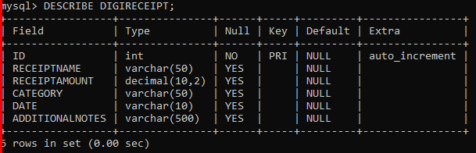

Starting Point

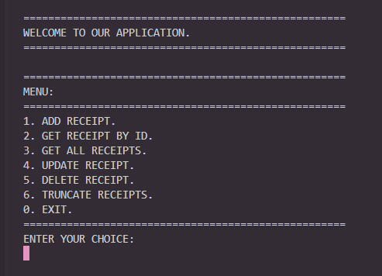

Validations

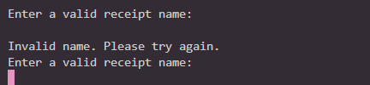

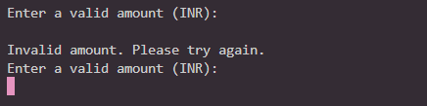

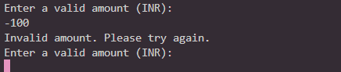

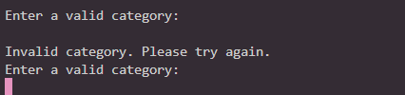

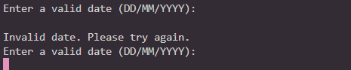

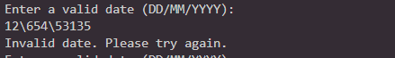

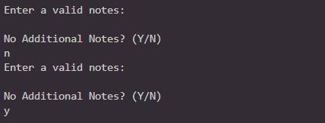

Add Data

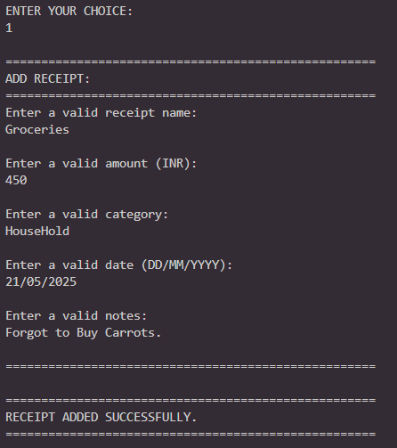

Reflection

Note: The data is different because I truncated the table prior to documentation.

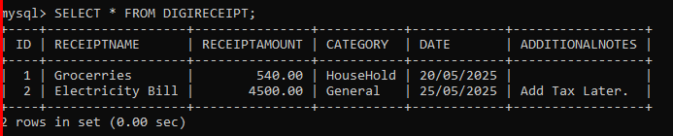

List All Data

Note: Despite entering “450” alone, the data is stored as decimal rounded off by 2 in default.

And is there is no additional details given during the adding process, the reflection is N/A.

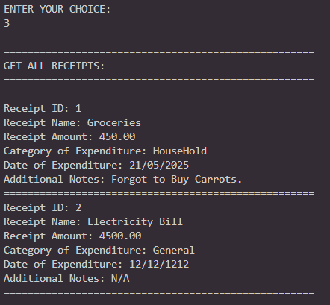
Search by ID

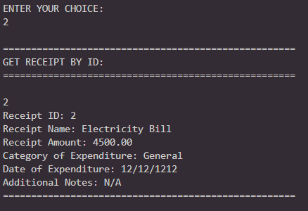
Update By ID

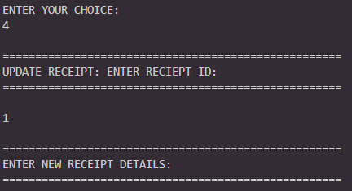

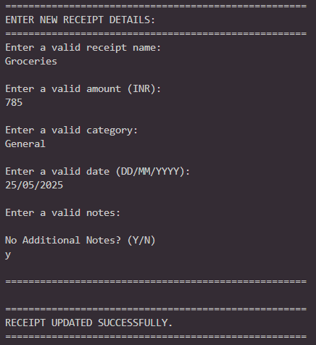

Reflection of Update

Note: The additional notes have been modifies to N/A due to no additional notes given during update.

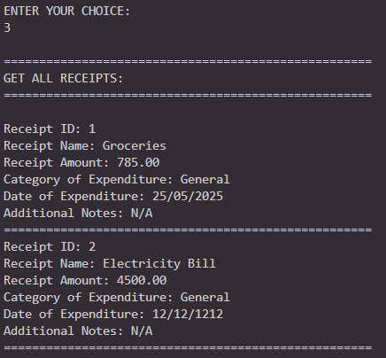
Deletion By ID

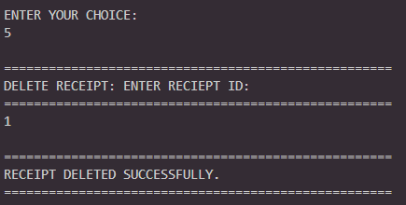

Reflection of Deletion

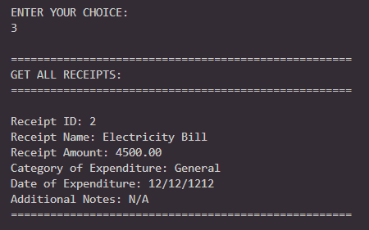
Additionally
Truncate (For Resetting DB during testing)

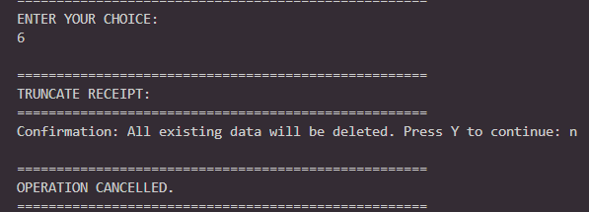

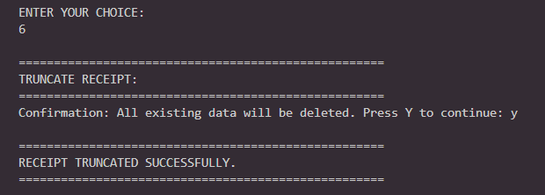
Event: Failures

Note: Database/Table is now empty.

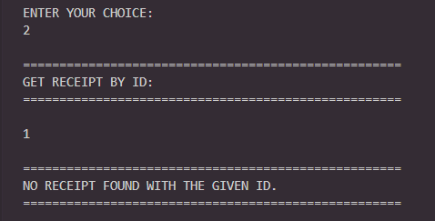

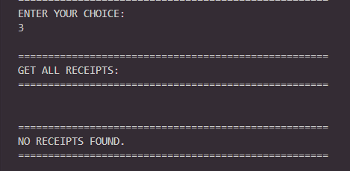

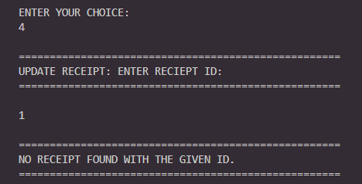

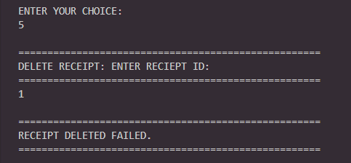
More Validations

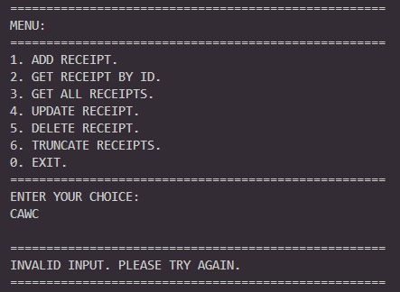

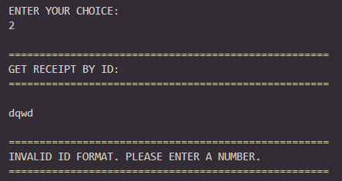

Note: The same validation for ID and Choice inputs carries over, everywhere in this app.

